From the Research Billing Review activity, the end user can verify that the patient’s charges have been adjudicated or assigned to the correct account (patient or study). The activity can display research information for both hospital and professional charges. End users can change whether the charge files to the patient’s account or the study account using the “Research Correction” button. When the charges are reviewed, the end user can clear the account by clicking “Mark Account (or Service Date for professional charges) as Reviewed.”

Try It Out

End users can review research charges using a variety of methods. At the top of the Research Home Dashboard, users can click the large “Click to Run the Report” play button. This pulls AGGREGATE data for all studies that the user has access to. Alternatively, the user can click the “UC Patients Needing Research Review (Coordinator)” link. This too pulls AGGREGATE data for all participants that have outstanding charges for all studies the end user has been given access to. Lastly, the user can click the “Pencil” to edit the report and pull charge data for an individual study
Method 1:
- Click the large “Click to Run the Report” play button.
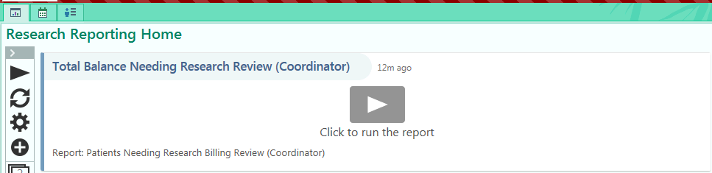

Method 2:
Click “UC Patients Needing Research Review (Coordinator)” under the Research Coordinator Dashboard reports.

Method 3: Click on the “Pencil” icon next to UC Patients Needing Research Review (Coordinator)
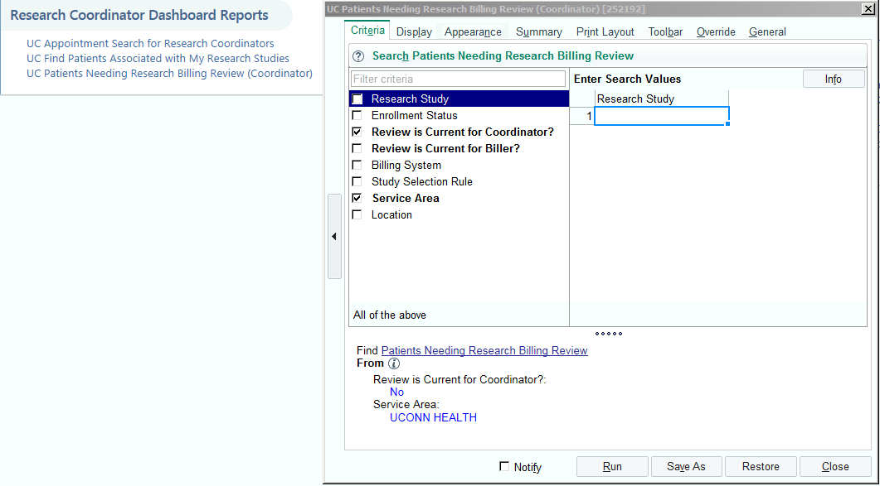

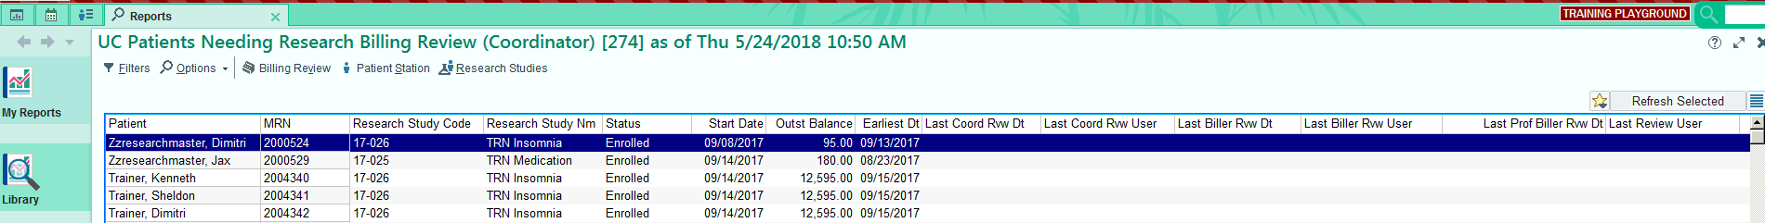
- With any method, a list of patients requiring research billing review will be displayed. The user should highlight the patient on which they will perform “Research Billing Review” and click the “Billing review” icon

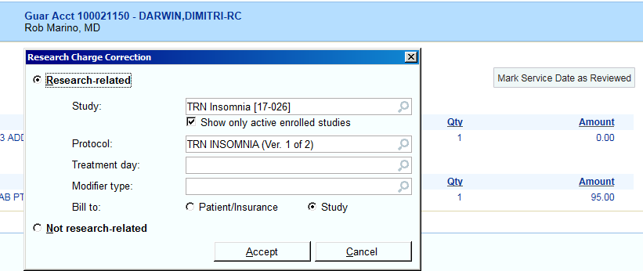
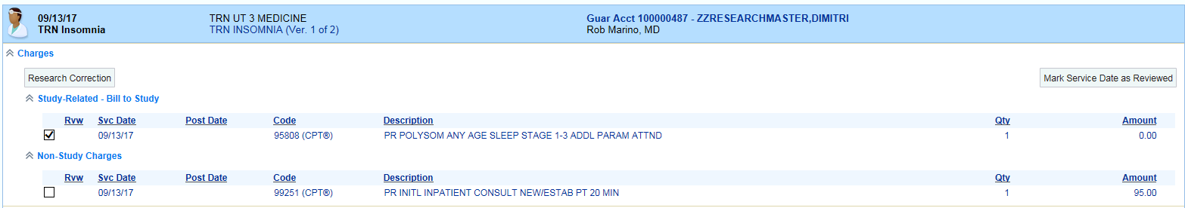
- Review charges for accuracy to ensure that research-related charges are appropriately being billed to the study or patient account. IF there is a correction to be done, check the box next to the appropriate charge and click “Research Correction.” Choose the correct account (moving patient charge to study or vice versa). Click “Accept”, and then click “Mark service date (or “Account” for hospital charges) as reviewed.”

You Can Also…
- Search for individual patients by clicking “Research Billing Review” under the dashboard’s Quick Launch to Research Activities. This activity allows the user to review ONE patient at a time.
- Search/Select for the patient by entering MRN (T0#) or patient name and click “Accept.” The patient’s individual charges will appear. Follow the same process outlined in Step 2 to review and accept charges.
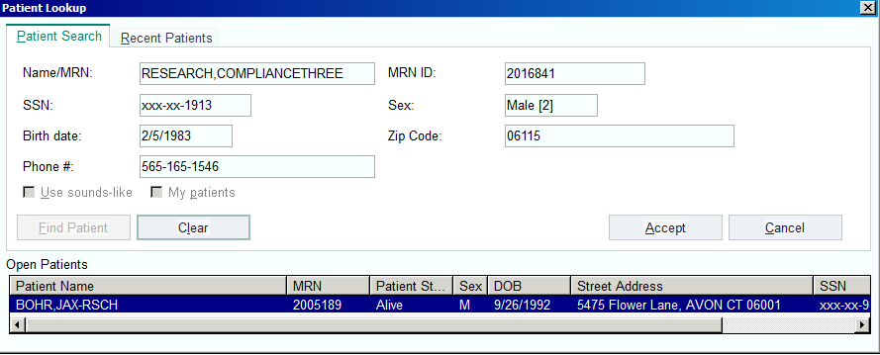

Did you know?

Q1 modifiers are charges that are research-related but are considered routine – will be billed to the patient’s account (insurance on file). Q0 modifiers are charge that are research-related /investigational and are going to be billed to the patient’s account. The Center for Medicare and Medicaid Services (CMS) requires that appropriate modifiers be on a hospital claim for accurate reimbursement. The correct application of modifiers ensures that UConn is not submitting False Claims. Modifiers are essential for correct billing and proper reimbursement.

