Try It Out

- To begin, click Releases on the top bar of the toolbar.
- Enter the patient’s name or MRN# in the highlighted box and click the “Magnifying Glass”. Alternatively, hit the “Magnifying Glass” to access the patient lookup window to search for a patient. Hit New Release to create a new record. *Note if a pop-up appears asking if the end-user wants to use an existing release, ALWAYS click New Release.
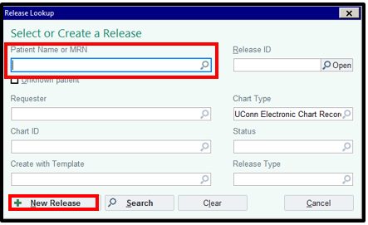

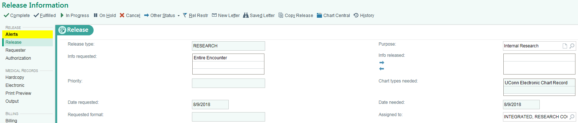
- Under the Release tab the “Release Type” is Research. The “Info requested” field will allow you to release the entire encounter or individual information.

The “Purpose” is either going to be Internal or External Research. Internal Research would be an internal audit and External Research would be a monitor visit.

- Under the Requester tab, click Third Party next to “Requested by” and enter “Research Monitor” next to “Requester”.

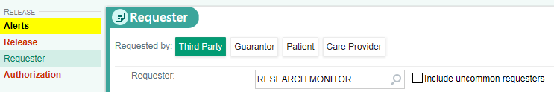
- Under the Authorization tab, click New Authorization
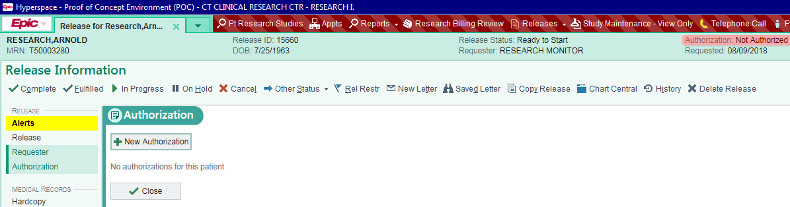

- Click the magnifying glass next to the “Type” box. Select Audit-No Authorization Required. Click Accept.

- Next, click the Electronic tab. depending on type of release you are doing Entire Encounter vs. Individual information you will be able to select information from different tabs.
Then doing Entire encounter, you can select only from Encounters tab. Make sure to uncheck “Hide Addt’l Visits” to ensure that ALL patient encounters appear.

When doing Individual information release, you can select from progress notes, labs, imaging, cardiology and media. Check the boxes next to the appropriate information.

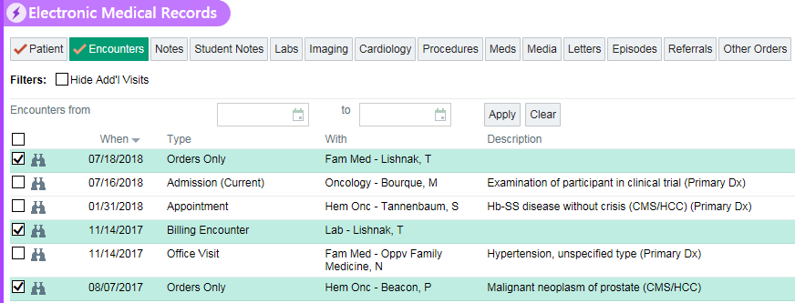

- Click the Print Preview tab, then click Keep Original Selection.
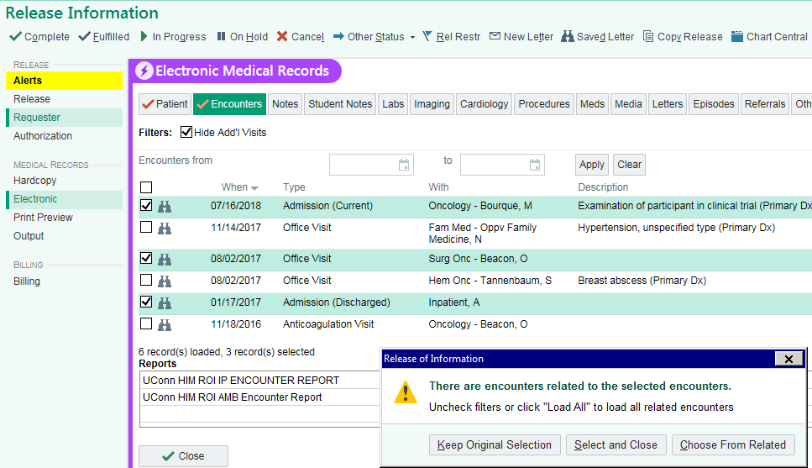

- Click Generate Preview. Note that the generation of the PDF Preview may take some time. Feel free to click the Refresh button periodically. Next, click View Preview to see the data elements available in the encounters that you previously selected.

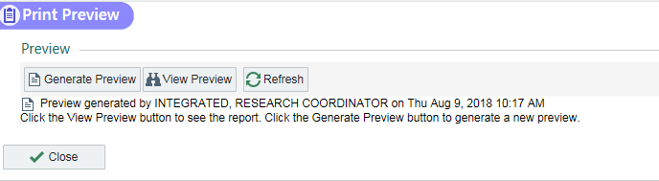

- To grant access to your research monitor, click Release To Inspector under “Output.” The “Change Status” box is a reminder that the patient is involved in a research study and that the end-user should take additional precautions. Click Yes.
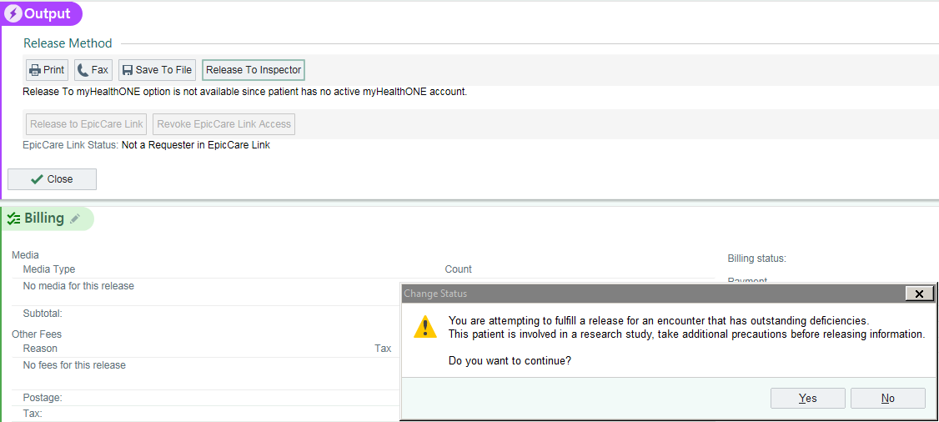

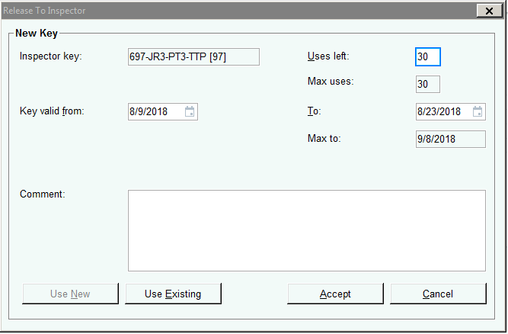
- The “Release To Inspector” box includes the “Inspector Key”. Write this down for your records. The end-user will give this key to the research monitor. The end-user can also determine how many uses the monitor can view the released information. Once completed, hit Accept.

- The inspector key will show up under “Output”. The end-user can edit the number of times the monitor may use the key produced by selecting the Edit button at any time. Also, the end-user can revoke the inspector’s access by clicking Revoke Inspector Access.

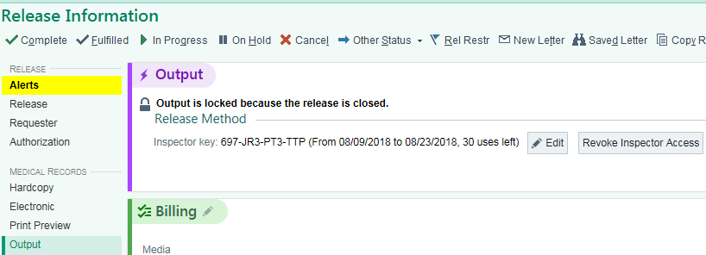

- The “Research Monitor” would then log into Epic with the username of “HIMROIINSPECTOR” and “epic” as the password. Once logged in, the Research Monitor would fill out the provided access key, name and organization. Then, the Research monitor would click Accept.

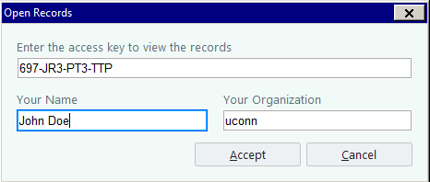

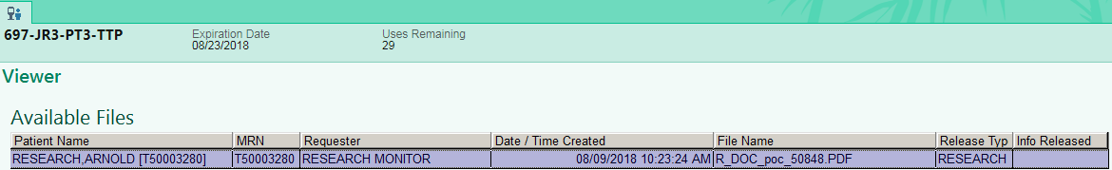
- The Research Monitor would then double click on the purple box to view the document(s).

