To schedule a research participant, utilize a “Quick Appt” followed by visit type, provider, appointment date and time, and visit length. This activity can be performed through the “Appointment Desk” button on the toolbar.

Try It Out

- Click “Appts” from the “Toolbar.” The patient lookup window opens.
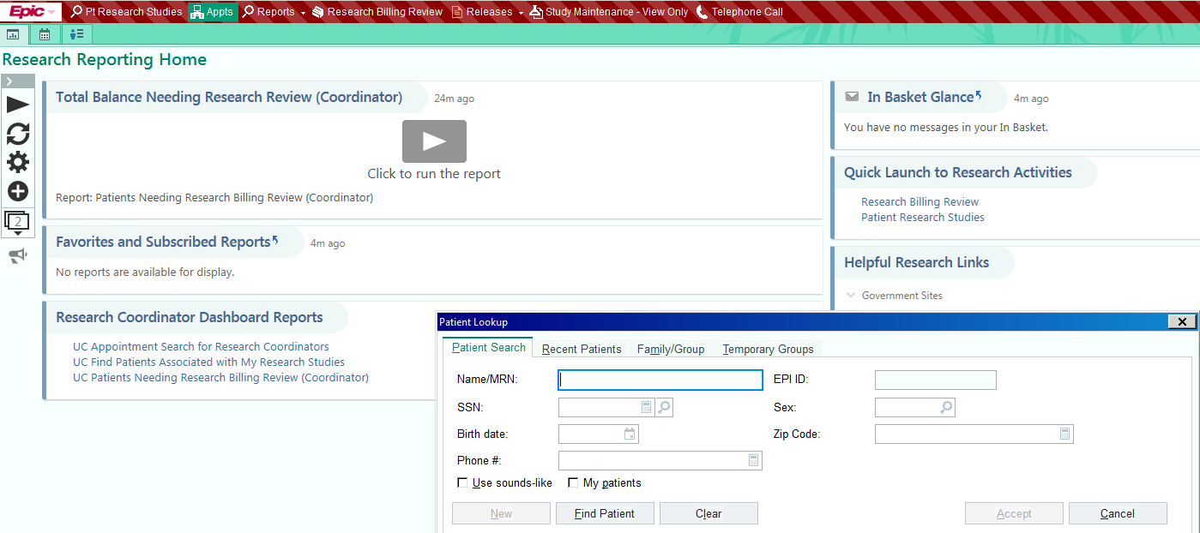

- Search/Select for the research participant by entering MRN (T0#) or patient name and click “Accept.”
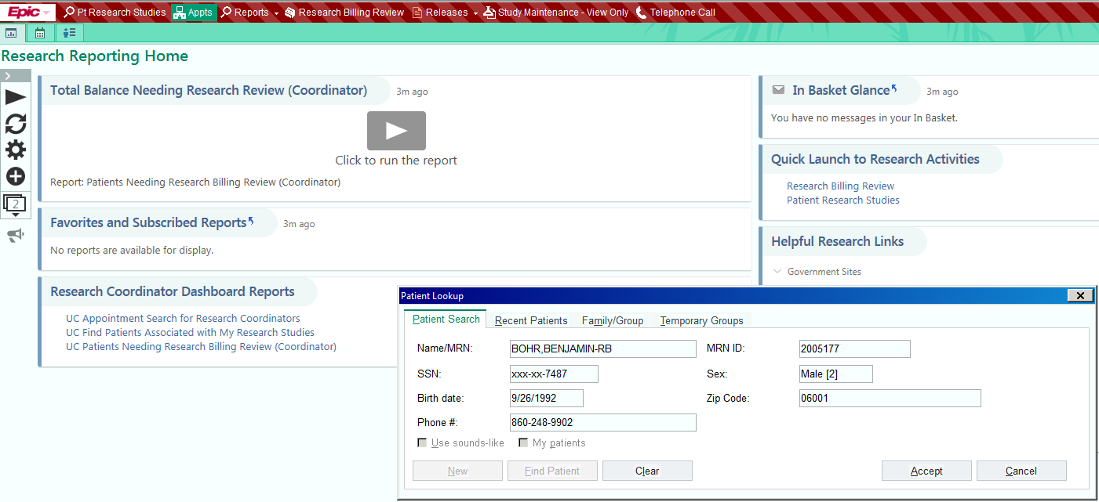

3. The research participant’s “Appointment Desk” opens
4. Click “Quick Appt” to schedule appointments.

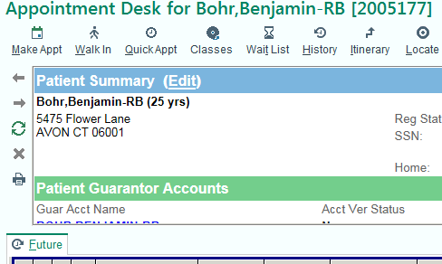

5. Complete the following fields: Department, Visit type, Provider/Resource, Appt time, and Length. Appointment Notes are optional. The selected provider’s schedule opens and the selected time is blocked in blue.

6. Click “Schedule”
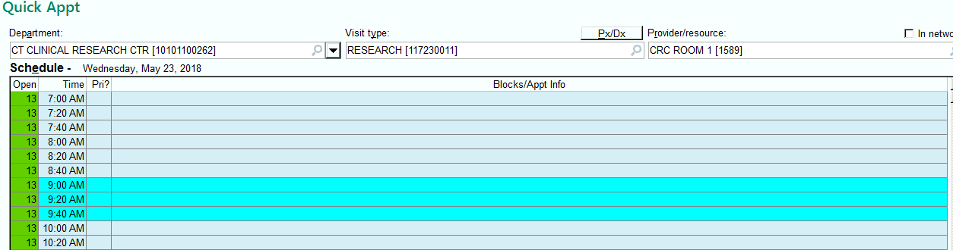

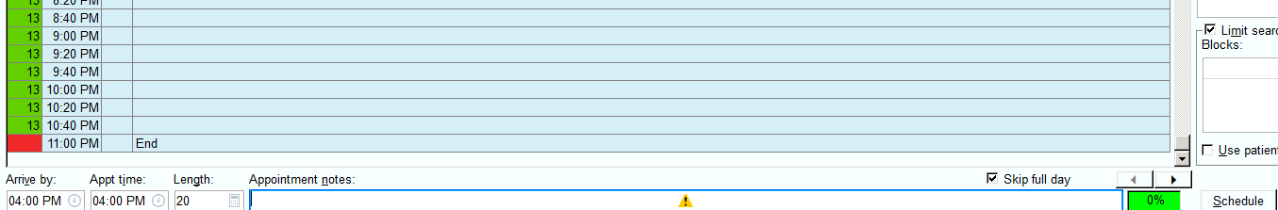

Confirm appointment details and click “Accept.”

7. Verify the research participant’s information that appears and edit as needed. Click “Accept.”

8. Click the blue link that says “The Liability /WC? is blank. Please input this information.” (most of the time the answer will be no) click “Accept” and then “Continue.”
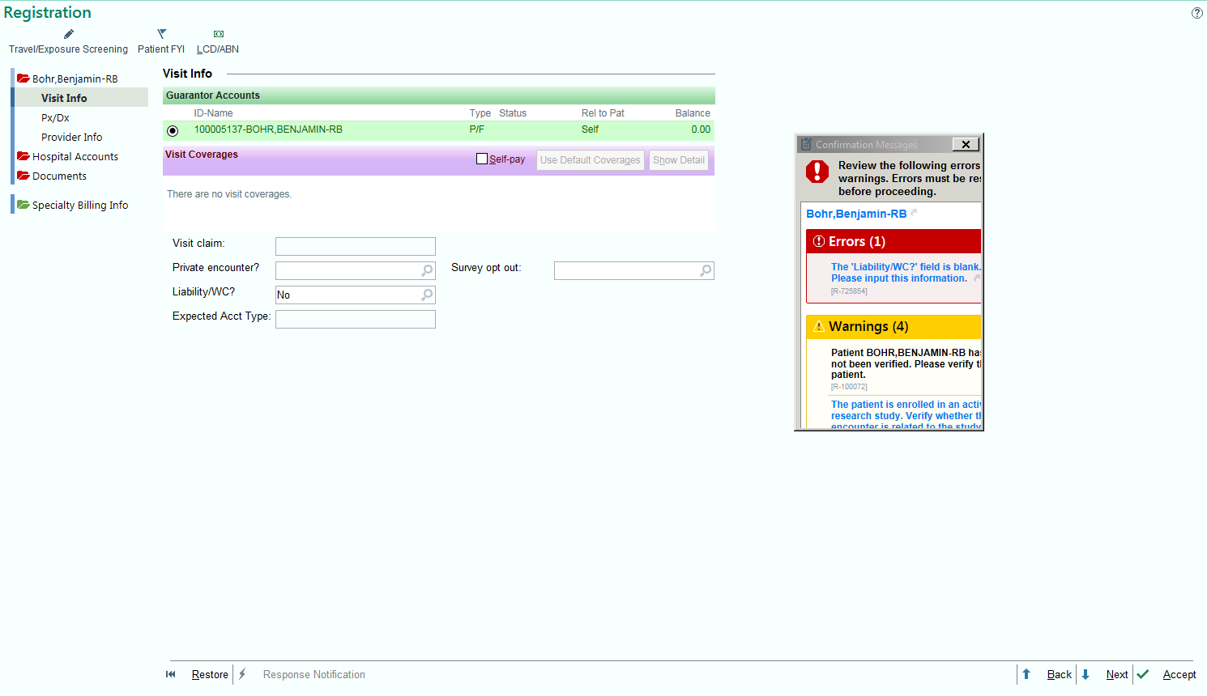

9. The scheduling activity is complete once the appointment for the research participant shows up under the Appointment Desk.

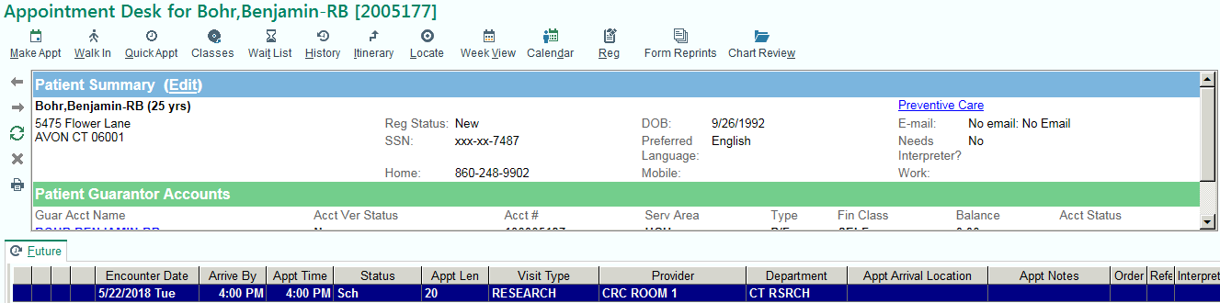

Did you know?

Some patients may be new to HealthONE. Should basic registration be needed, the following information may be helpful.

- Type in name of new research participant. Click Find Patient. A message will appear that says “A matching patient was not found.” Click Continue.
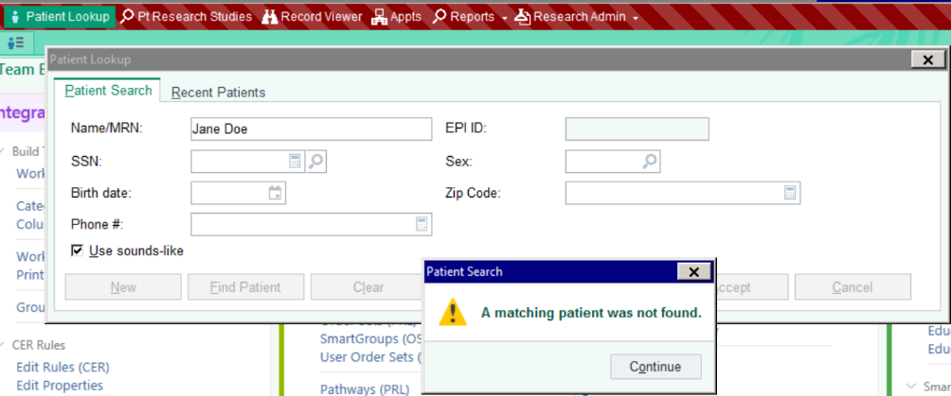

- Fill out selected fields. Click New.
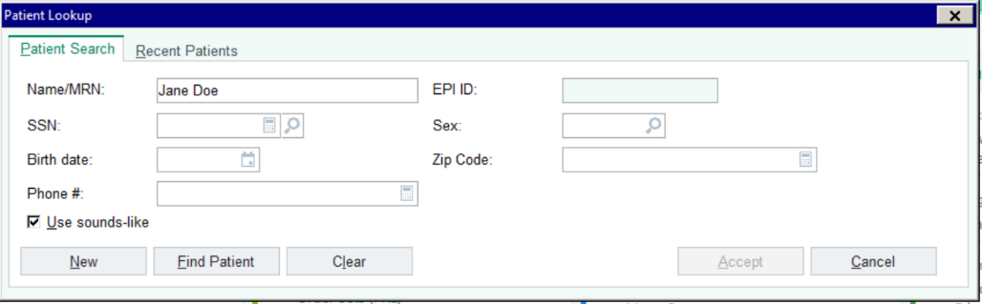

- Now that the patient has been added, registration can be completed by setting up an appointment. Click Appts.
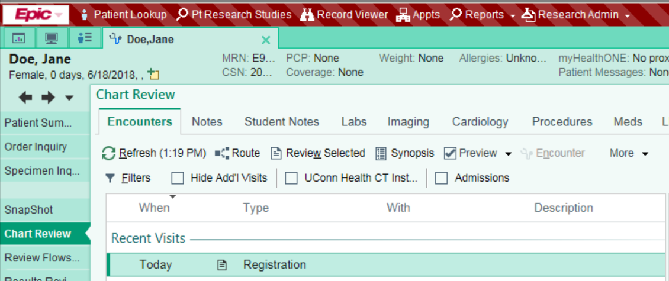

- Double click on research participant’s name
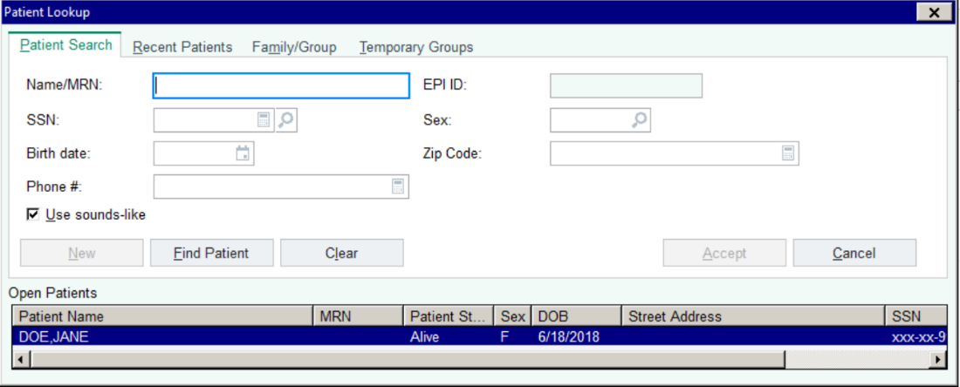

- Click Quick Appt.
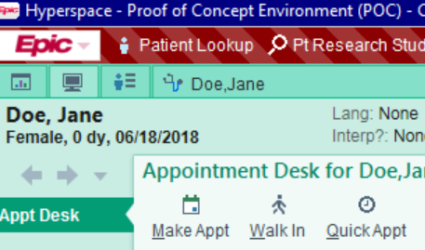

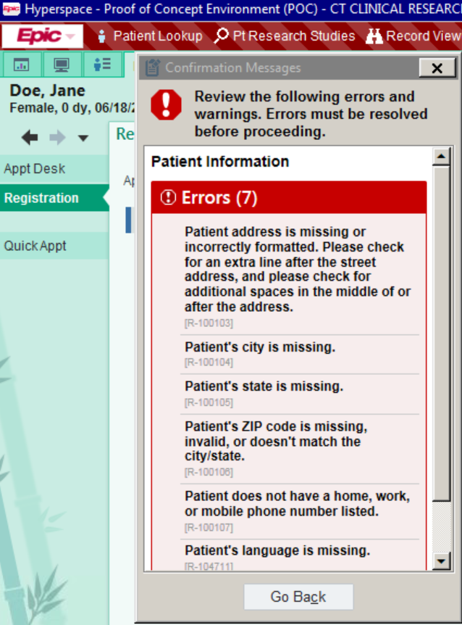
- Click Go Back to review the following errors and warnings to complete registration.

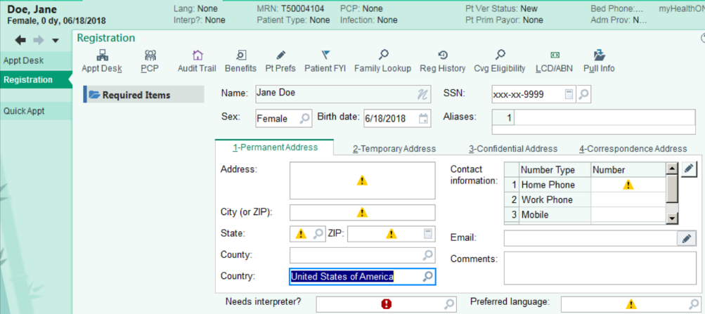
- Note the following fields need to be filled out to complete registration.

- The new research participant can now be scheduled.
