The following work flow should be followed in order to order a medication, pend that order and sign it from an In Basket message.

Try It Out
- To begin, click the “Calendar Icon” from the Home Dashboard. Double click on the appropriate patient’s encounter.
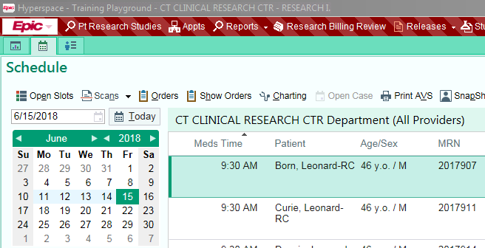

- Within the individual encounter, add the appropraite order. Click +New Order after entering the appropriate search word.
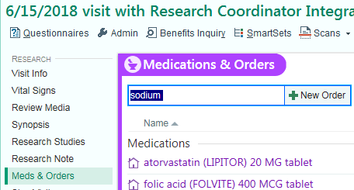

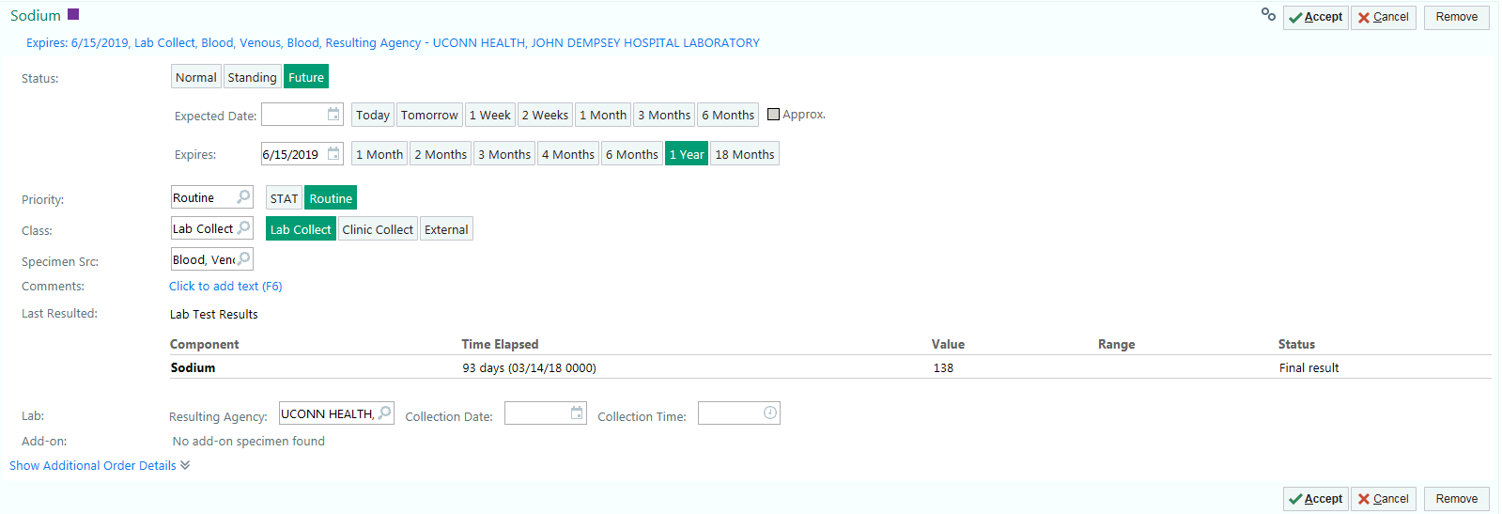
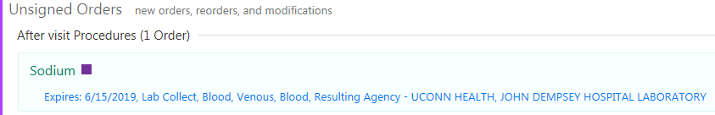
- After selecting the order under Unsigned Orders, click on order’s hyperlink to change the selected fields below as needed. Click Accept. *Note make sure that the Resulting agency is directed to the correct place.

- Click Pend. *Note that once the order is pended, the Star Icon will disappear.

- Click In Basket Message from the Dashboard.
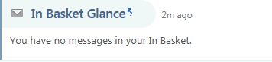

- Click New Msg.

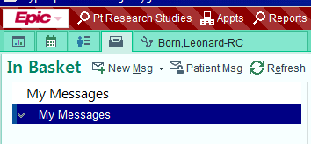

- Fill out the selected fields. *Note that the patient field needs to be filled out so that the authorizing provider can access the patient’s chart. Click Accept.
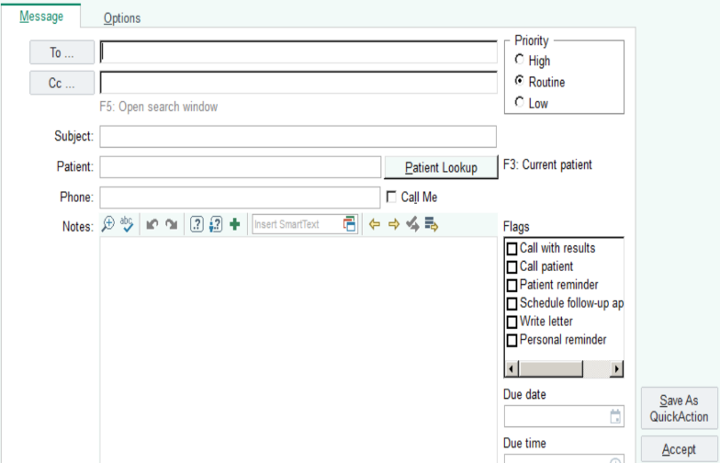

In order to sign an order through an In Basket message, the following workflow should be followed.
- To sign the order from an In Basket message, begin by clicking In Basket Glance from the Home Dashboard (or from the Epic menu/toolbar if customized.

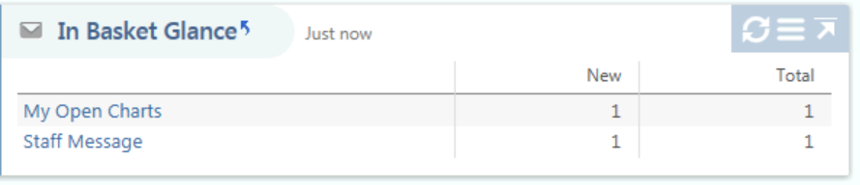

- Click Staff Message.
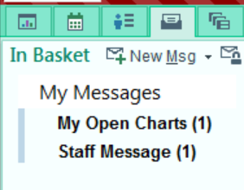

- Double click on the appropriate staff message to enter the participant’s Chart. The Encounters tab will be the defaulted view.
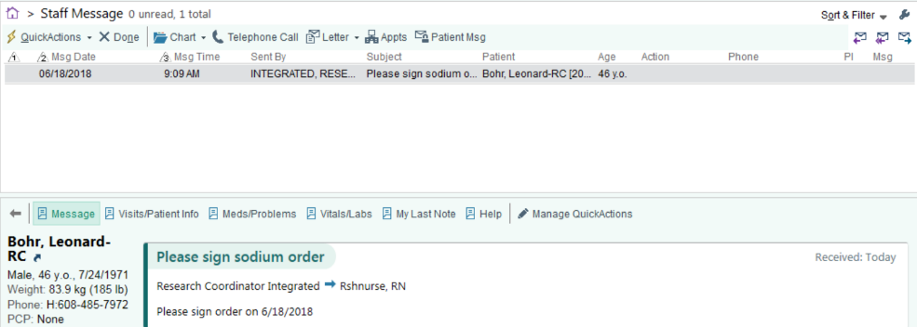

- While on the Encounters tab, the Hide Add’l Visits box must be unchecked. Select the appropriate encounter at which the order is being performed.
*Note: Do NOT double-click on the selected encounter.
- Instead, with the appropriate encounter highlighted, click Encounter as displayed in the image below.
*Note that the pending order requiring signature will show up in the preview box to the right of the selected encounter.
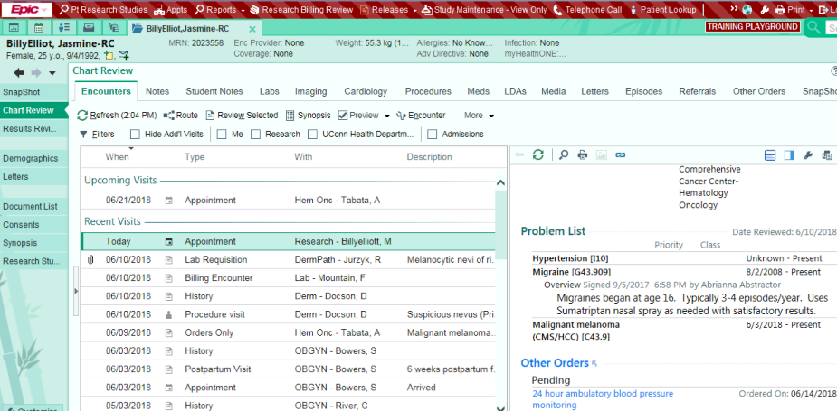

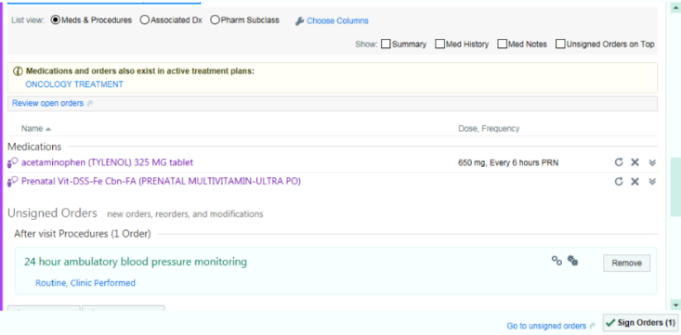
- Under Unsigned Orders, the appropriate order will be displayed. Click Sign Orders.

