End-users can administer medications while in the clinic (known in HealthONE as “clinic-administered medications) through the Meds and Orders tab under the Visit Navigator or the MAR tab. Administering the medication allows users to document the date and time of the drug administration, the administration route and site, dose and rate (if applicable).

Try It Out
Method 1:
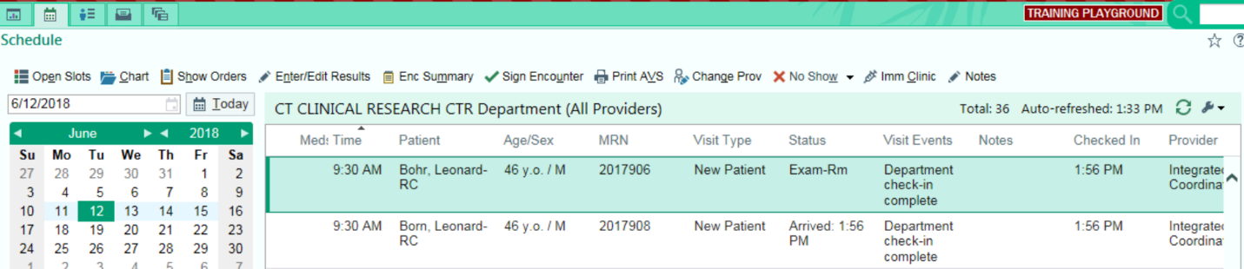
- To begin, click the “Calendar Icon” to view scheduled appointments for participants on a specified day.

- Select the appropriate appointment of the particpant and double click. This leads to the Visit Navigator. Click on the Meds & Orders link. Here the user will see any medication orders that have been placed. Note that medications to be given AFTER the visit (outside of the clinic) are indicated by a small house icon. Medications that should be administered within the clinic are marked with a small needle icon.
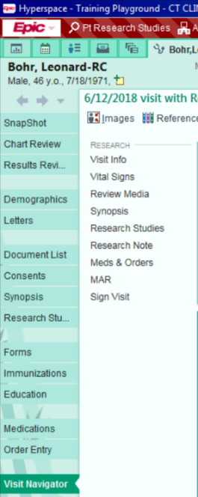

- Click on the Needle Icon next to the name of the medication that needs to be administered. Next, click on the Needle Icon next to Administer.
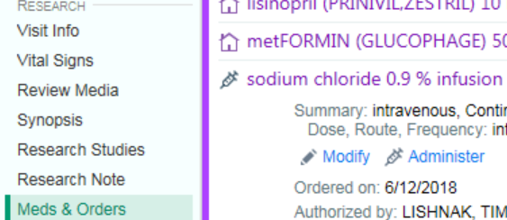

- Fill out all appropriate fields to document medication administration and click “Accept”.
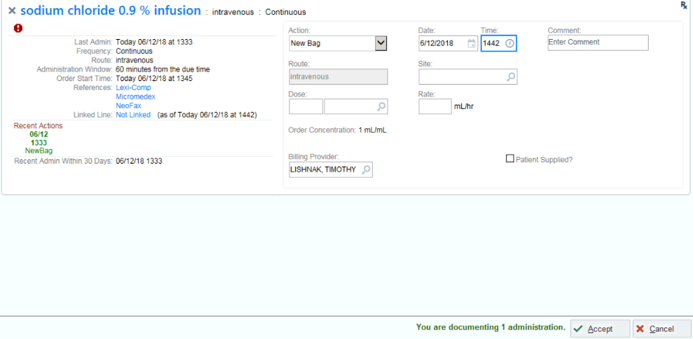

- The medication has been administered once the time stamp has appeared.
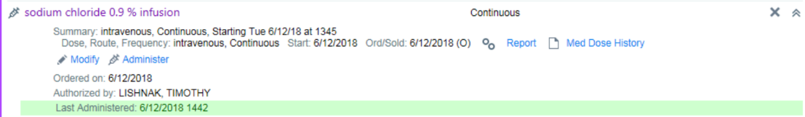

Method 2:
- To begin, click the “Calendar Icon” to view scheduled appointments for participants on a specified day.
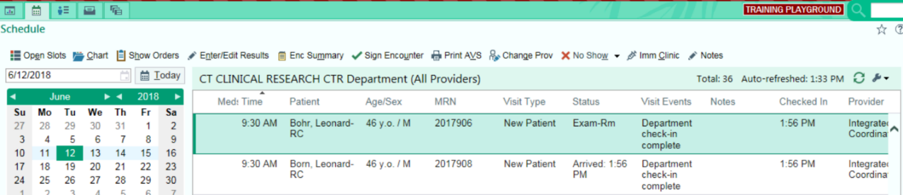

- Select the appropriate appointment of the participant and double click. This leads to the Visit navigator. Click on the MAR link.
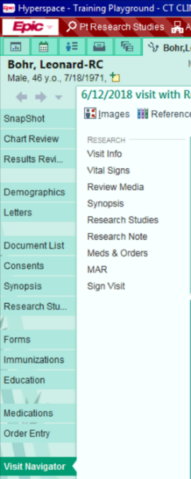

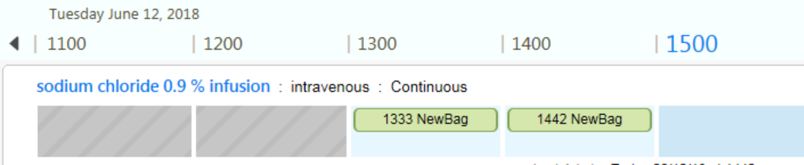
- Click on the appropriate medication that needs to be documented.

- Repeat steps 4 and 5 located in method 1.

