This process outlines how clinic staff need to generate labels for clinic-collected specimens.

Try It Out

- To begin, click the “Calendar Icon” to view scheduled appointments for research participants. Single click on the appropriate research participant’s appointment.

- Ensure that the user has selected Visit Orders from the selection menu on the right-hand side of the screen.

- Click “Collect Specimens” under Orders Needing Specimen Collection.
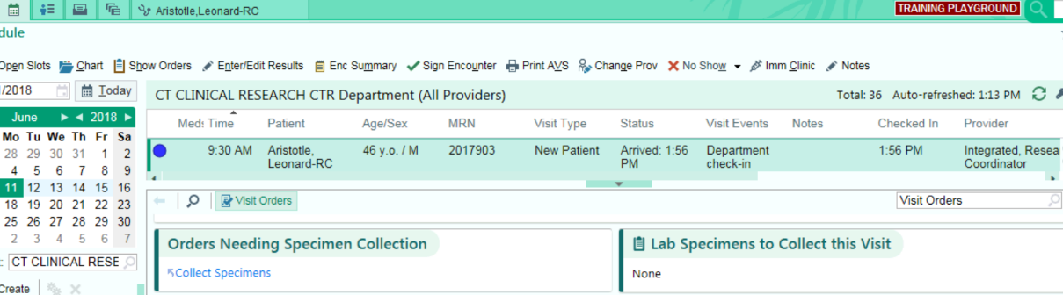

- Click “Collect Specimens.” Note that HealthONE will indicate the correct tube/collection method and minimum volume (if appropriate) for each test ordered.
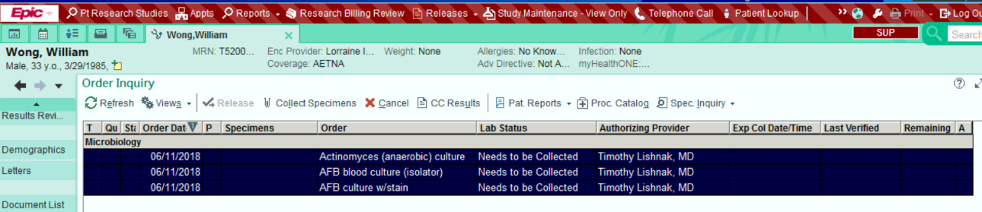
*Note that all specimens that need to be collected must be highlighted.

- Click “Print Label.”
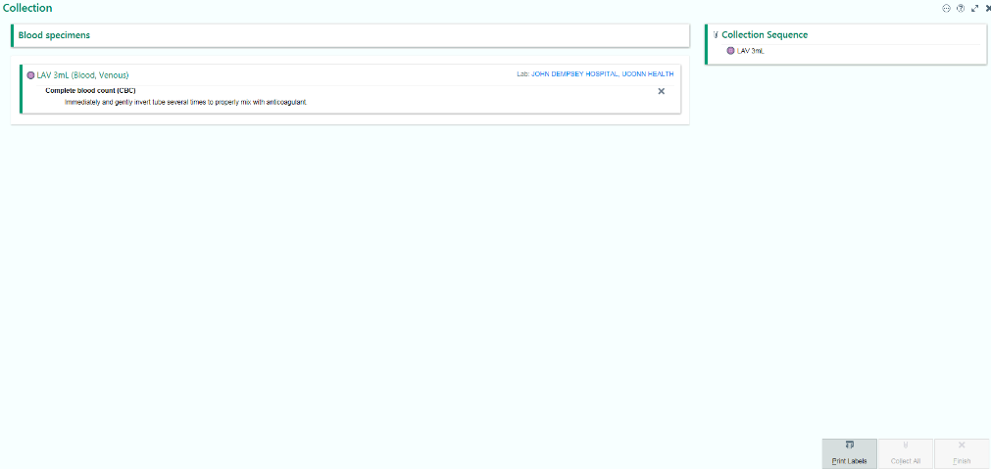

- Click “Collect All” then click “Finish”. The specimens can now be sent
