The patient must have an active association with a research study before you can associate any orders with it, and you can associate an order with only one study. It makes billing easier for study-associated orders and helps with identifying and filtering study-related results.

Try It Out

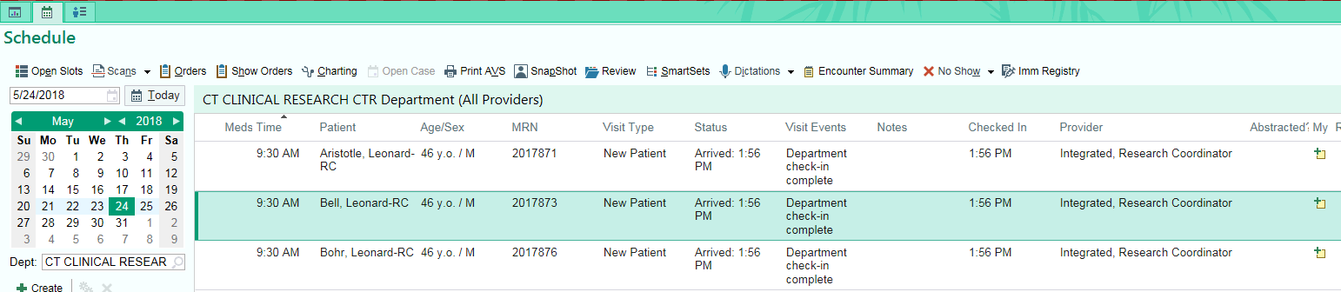
- To begin, click the “Calendar Icon” to view research participants’ appointments. Select the appropriate research participant appointment and double click. The Visit Navigator will appear.

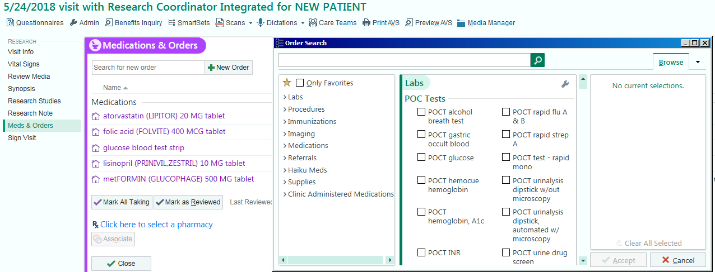
- Under the Visit Navigator click “Meds & Orders.” Search for the medication or order in the Search for new order box OR click “+ New Order” to search from a list.

- Double click on the appropriate medication or order. The medication or order will appear on the right hand side under the After Visit Medication OR Procedure. Click “Accept.”
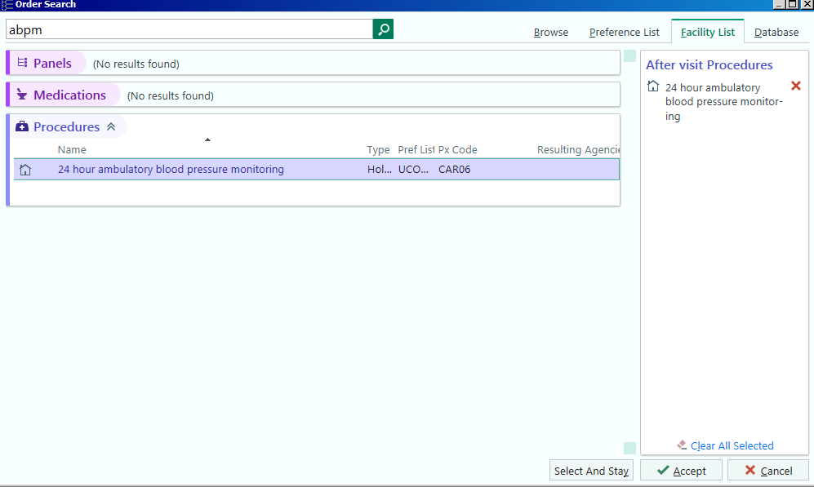

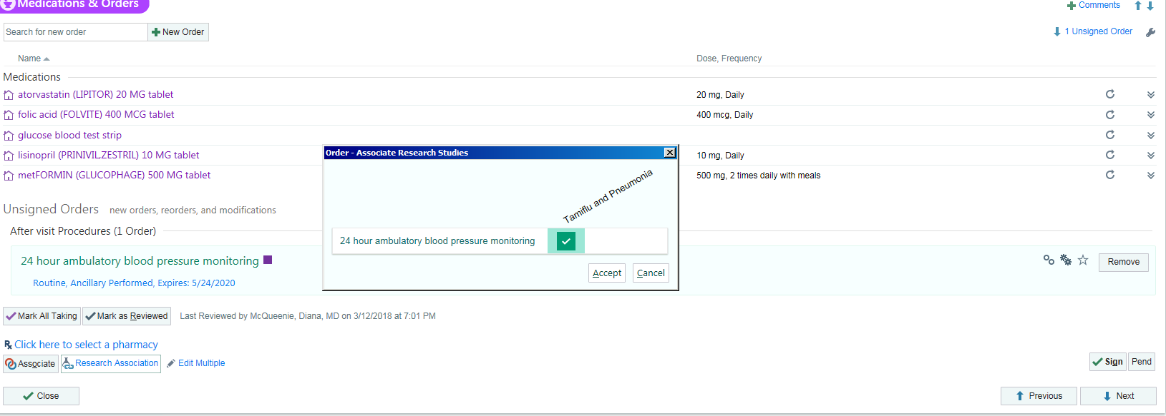
- Under Unsigned Orders, click “Research Association” then check the appropriate study. Click “Accept”

- The order association is completed once the Linked Beaker Icon appears.
