Associating research participants to a study is required for accurate research billing and adjudication of research-related charges. This activity can be found under the Quick Launch to Research Activities – “Patient Research Studies.”

Try It Out
- Start by clicking “Patient Research Studies” under the Quick Launch to Research Activities dashboard component. This is located on the right side of the dashboard.
- Search for the participant by MRN (T0#) or name (last name, first name). Click “Find Patient.” If there is more than one option, ensure to choose the research participant that has consented to the study and click “Select.”
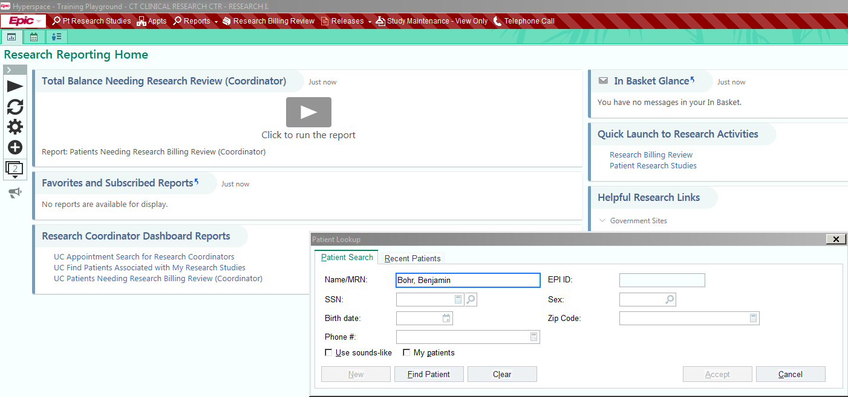

- Click the “+Add” and select the correct study from the list. Click “Accept.” Note that the list that appears displays ONLY the studies that the user has been granted access to.
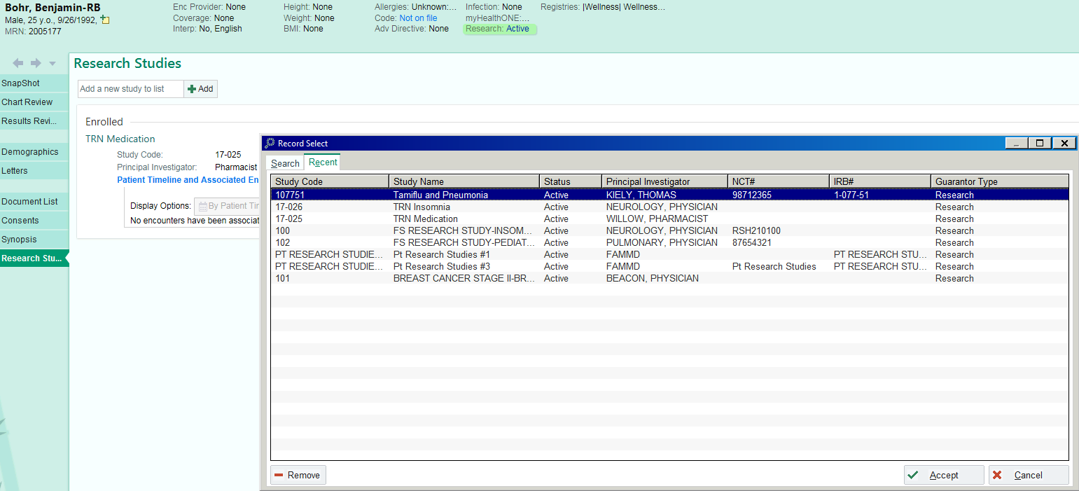

- Two data elements are required for Participant/Study Association: Status and Active Start Date. Click the magnifying glass icon next to the status: box and choose the option that best describes the participant’s current enrollment status. NOTE that research billing ONLY works when the participant has been placed in the Consented/Enrolled status. Click “Accept.” Active Start Date is defined as the
date of the research participant’s date of consent. To document, Click the calendar icon next to the Active Start Date: box. Choose the correct date and click “Accept.”
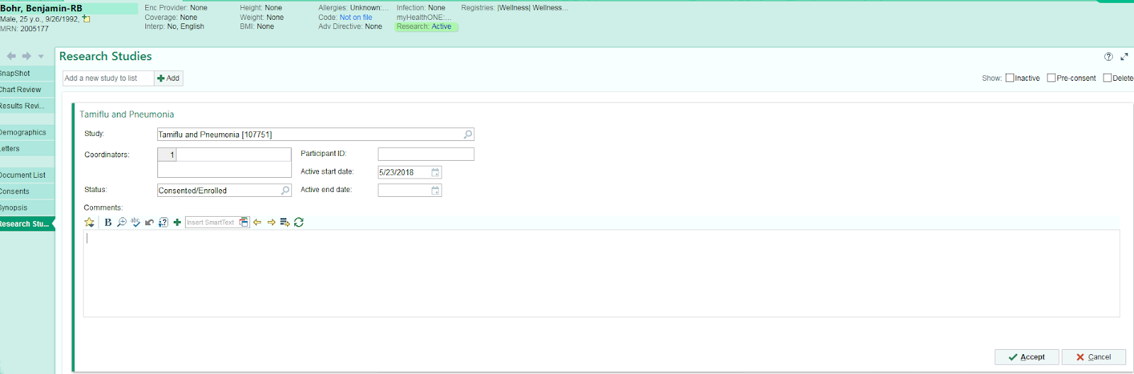

5. To complete the participant/study association, a timeline should be generated. A timeline creates a PROPOSED study visit schedule based on the protocol calendar built by HealthONE. A timeline ensures that research billing is accurate. Click the “+Add to Timeline” to create a research participant timeline. To begin, enter the From Date. The From Date should align with the first actual study visit. Once the From Date is entered, click the “Tab” button and always choose “Set Subsequent Dates” to auto-populate the rest of the proposed visit schedule. Click “Accept” to finish.
