Associated research study staff can link an encounter to a study from the Research Home Dashboard. Encounters should be linked before the visit begins to ensure that the patient and/or the study are billed appropriately.

- Start by clicking the “Pencil Icon” next to UC Appointment Search for Research Coordinators.
Ensure that the Research Study ID is correct and the Enrollment Status is Consented/Enrolled. Click “Run.”
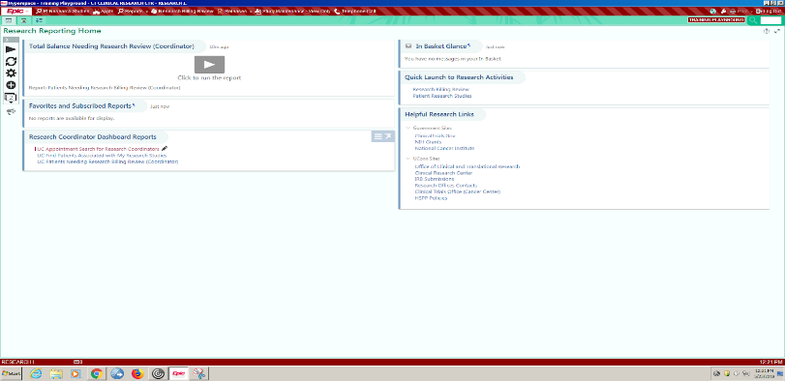
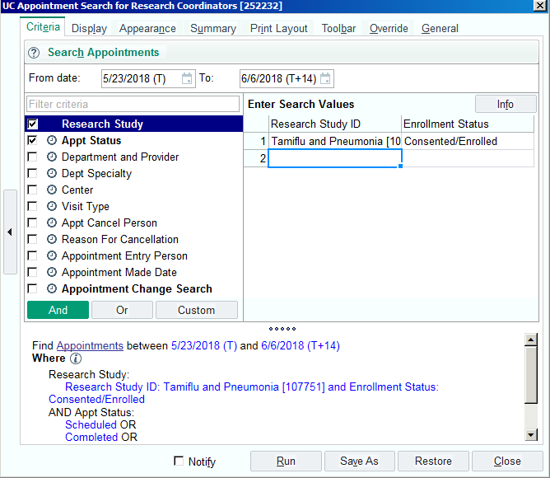

- All of the research participants that have been associated with the identified study AND are in the
Consented/Enrolled status will appear on the Research Study Report with the research participant’s appointment. Right click on the appropriate research participant’s appointment and click “Link to Research Study.”
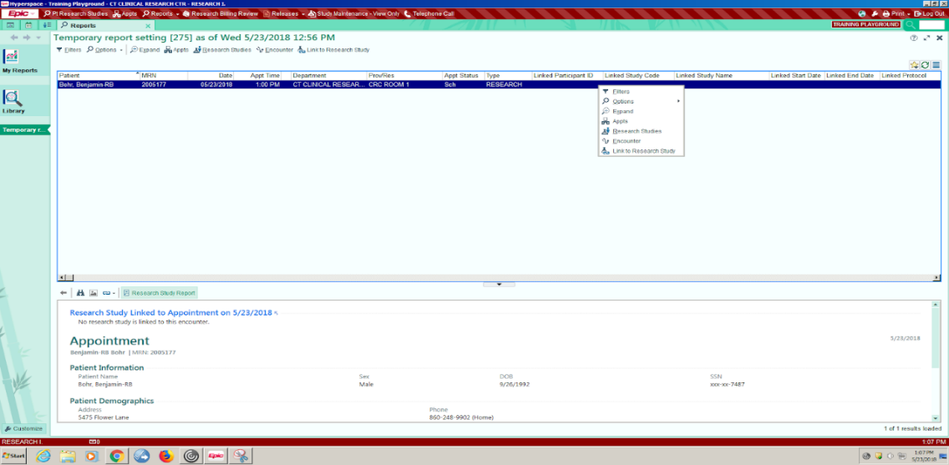

- 3. Check the appropriate study. Click “Accept.” Next, choose the appropriate visit for which the
- research participant will be having. Click “Accept.”

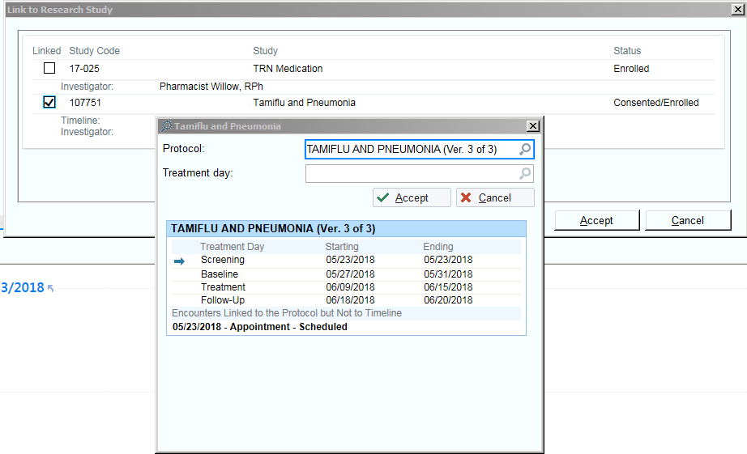

- The associating encounter to study activity is complete once the Linked Research/Beaker Icon appears next to the Appt Time.

You Can Also…
Link the Encounter to the study from the research participant’s Appointment Desk by right clicking on the appropriate encounter and clicking “Link Research Study.”

